**SUPPLEMENTARY FIGURES AND TABLES**

**to accompany**

**Effect of Routing Errors on the   
Psychometric Properties of Multistage Tests**

**by**

**Robert Chapman, David J. Weiss, and King Yiu Suen**

**University of Minnesota**

**Figure S-1. Module Information Functions for 1-3-3 and 1-3-4 MST Designs by Assembly Method,   
with Equal Number of Items per Stage, Averaged across Five Panels**

1. A group of graphs with lines

   Description automatically generated**1-3-3 MST**

**Figure S-1. Module Information Functions for 1-3-3 and 1-3-4 MST Designs by Assembly Method,   
with Equal Number of Items per Stage, Averaged across Five Panels (continued)**

1. **1-3-4 MST**

**Figure S-2. Mean Conditional Percentage of Simulees with Routing Errors**

1. **Maximum Information-Based Routing, 1-3-3 Design**

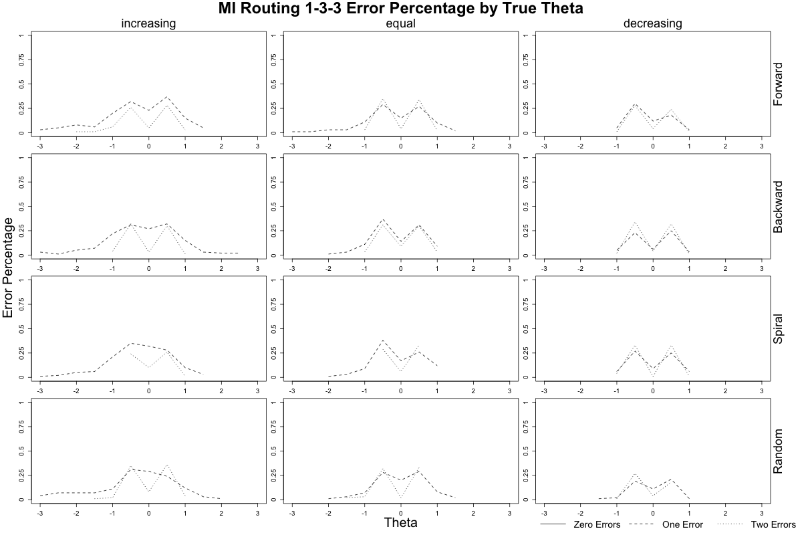

1. **Figure S-2. Mean Conditional Percentage of Simulees with Routing Errors (continued)**
2. **Maximum Information-Based Routing, 1-3-4 Design**

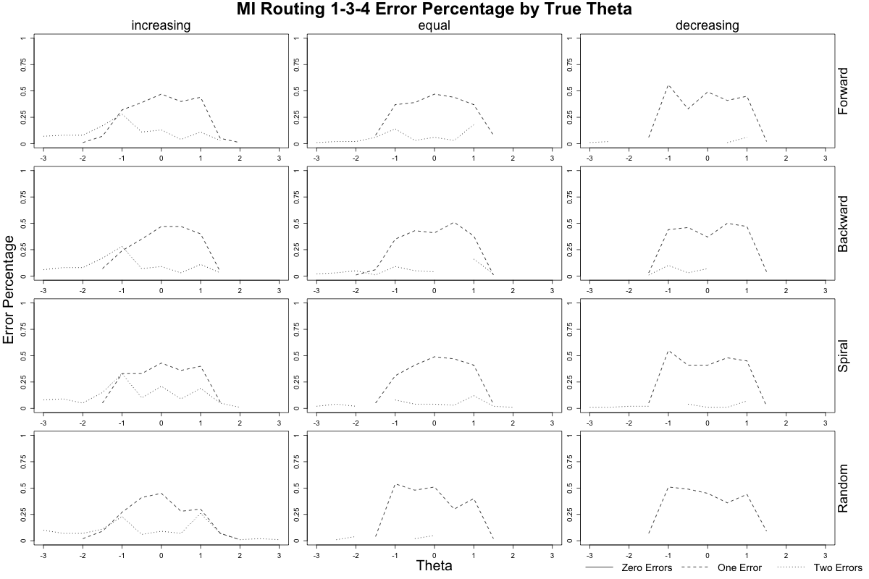

1. **Figure S-2. Mean Conditional Percentage of Simulees with Routing Errors (continued)**
2. **Population Distribution Interval, *θ* -Based Routing, 1-3-3 Design**

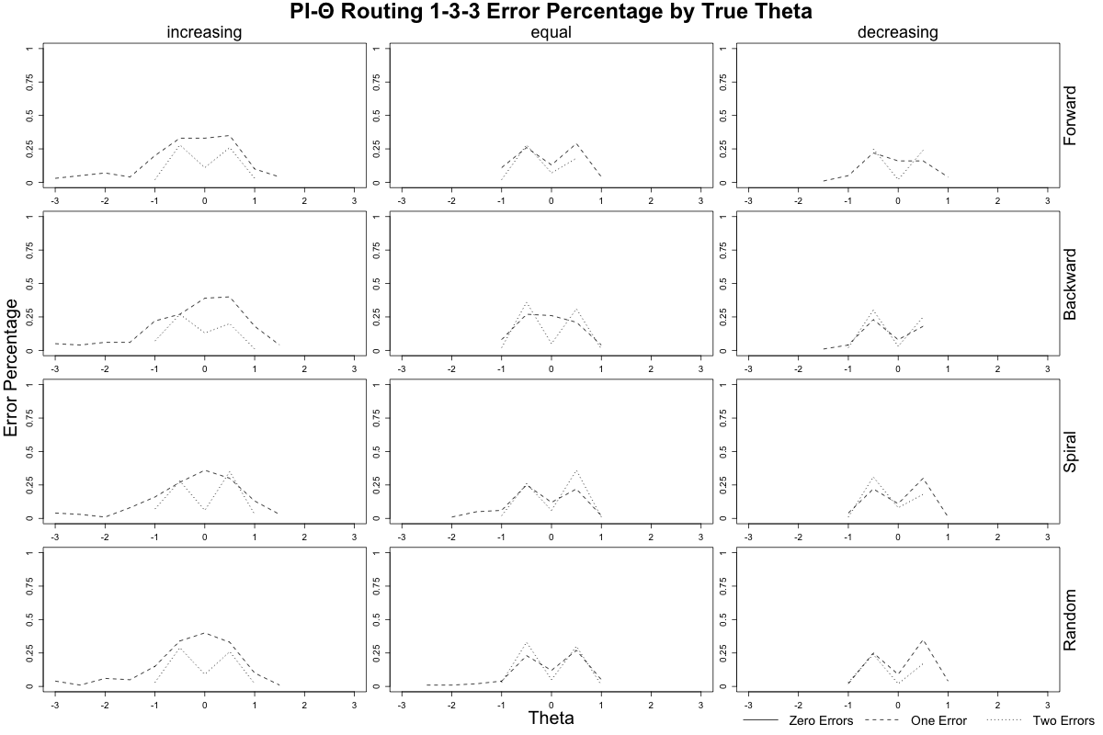

1. **Figure S-2. Mean Conditional Percentage of Simulees with Routing Errors (continued)**
2. **Population Distribution Interval, *θ* -Based Routing, 1-3-4 Design**

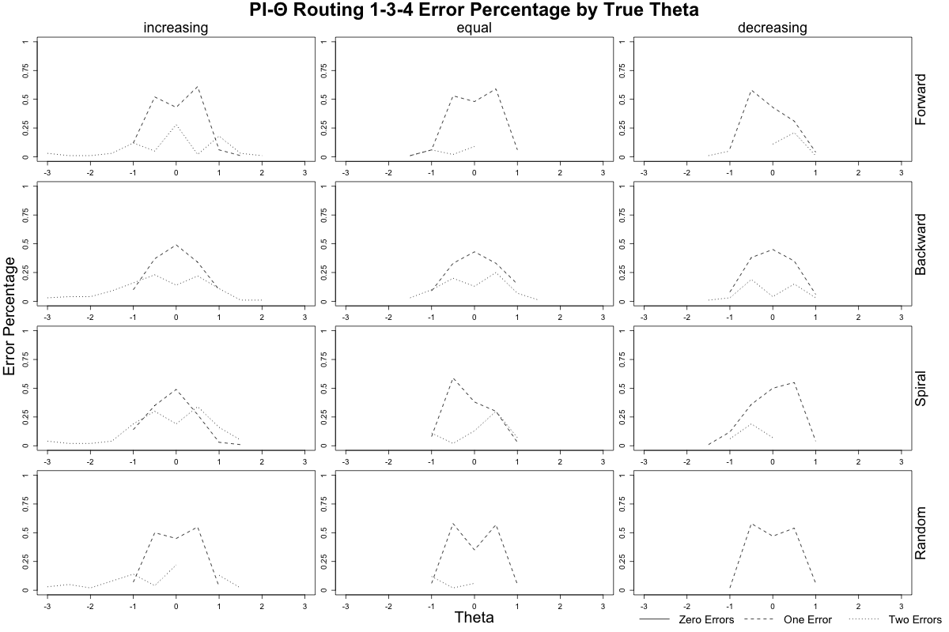

**Figure S-2. Mean Conditional Percentage of Simulees with Routing Errors (continued)**

1. **Population Distribution Interval, Number-Correct-Based Routing, 1-3-3 Design**

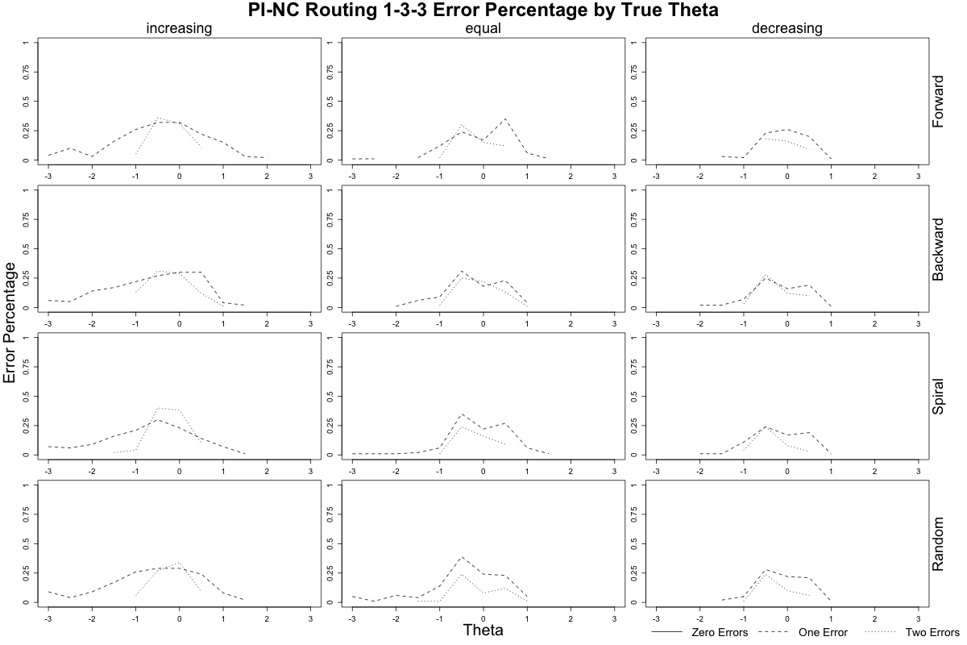

**Figure S-2. Mean Conditional Percentage of Simulees with Routing Errors (continued)**

1. **Population Distribution Interval, Number-Correct Based Routing, 1-3-4 Design**

**Figure S-3. Mean Conditional Bias**

1. **Maximum Information-Based Routing, 1-3-3 Design**

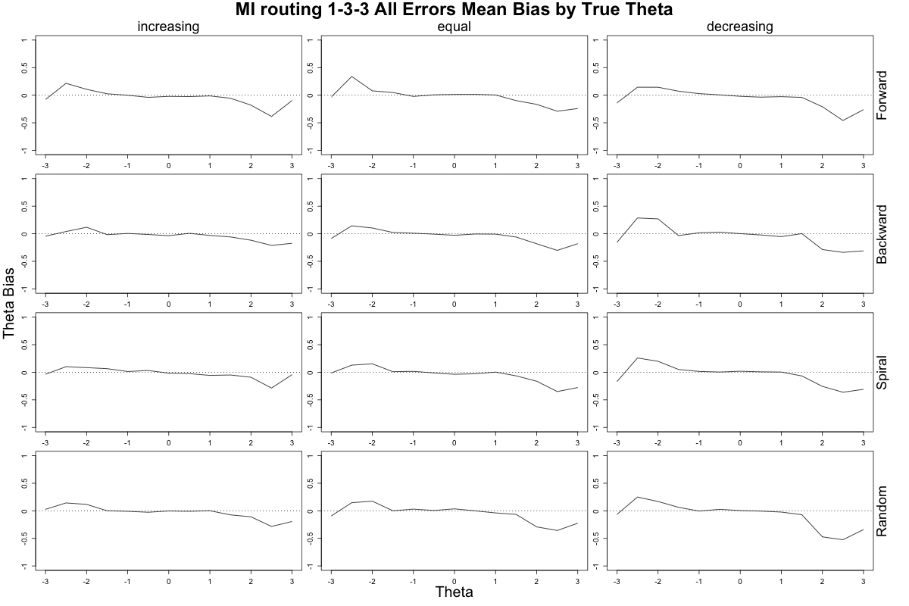

**Figure S-3. Mean Conditional Bias (continued)**

1. **Maximum Information-Based Routing, 1-3-4 Design**

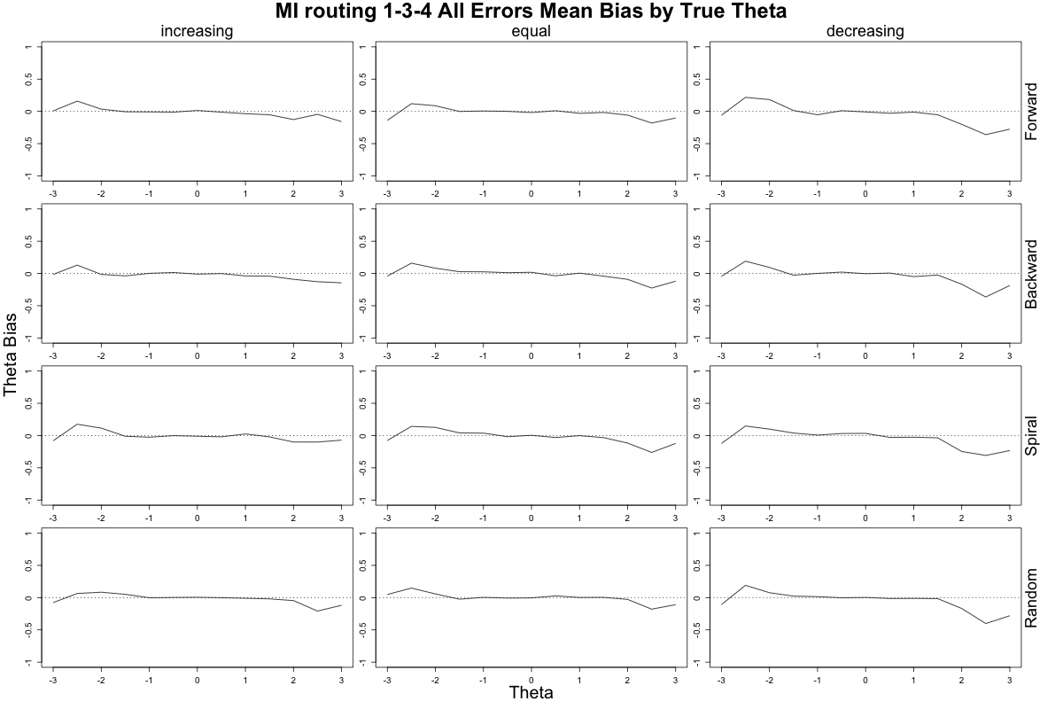

**Figure S-3. Mean Conditional Bias (continued)**

1. **Population Distribution Interval, θ-Based Routing, 1-3-3 Design**

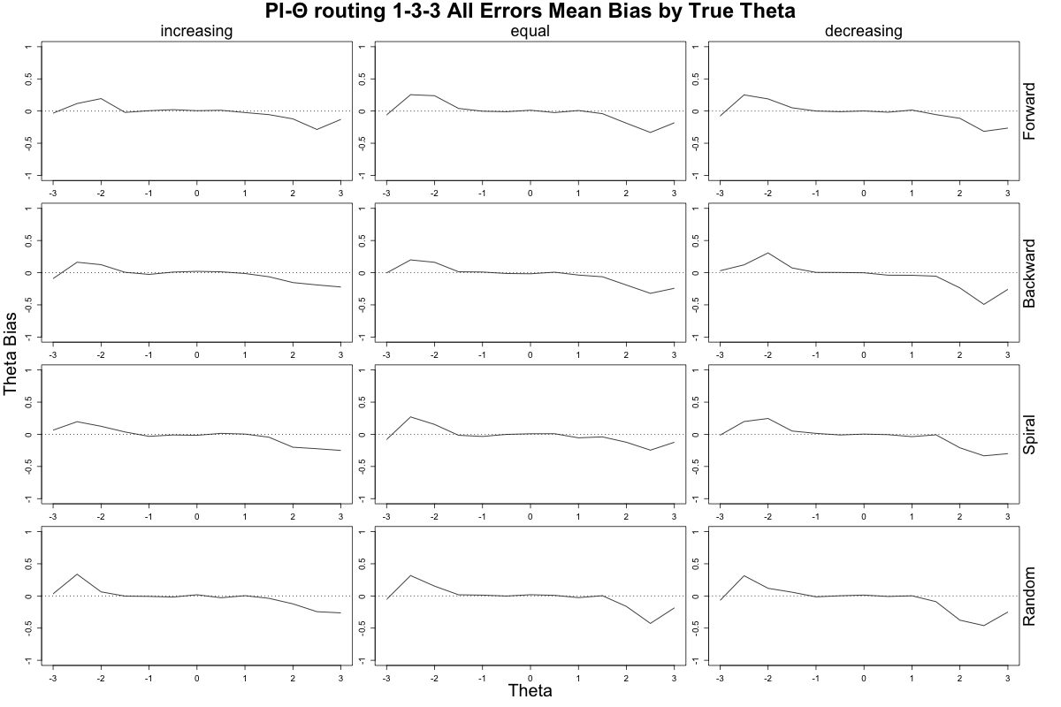

**Figure S-3. Mean Conditional Bias (continued)**

1. **Population Distribution Interval – θ Based Routing, 1-3-4 Design**

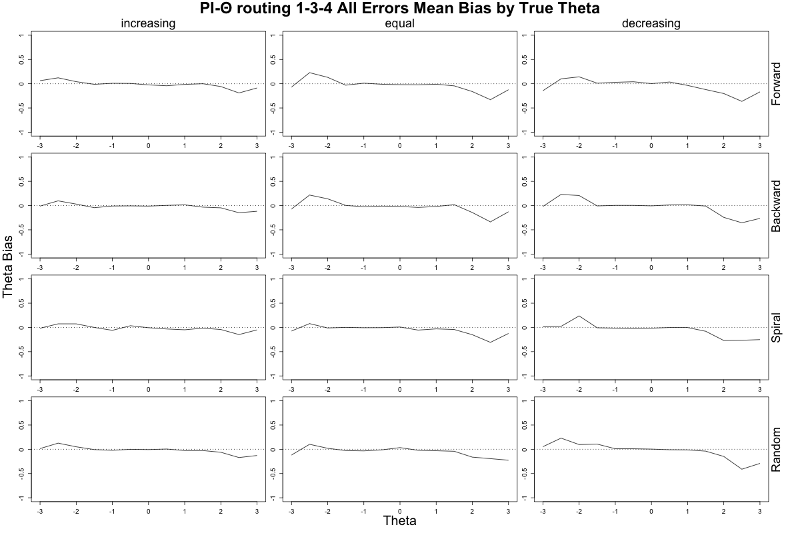

**Figure S-3. Mean Conditional Bias (continued)**

1. **Population Distribution Interval , Number-Correct Based Routing, 1-3-3 Design**

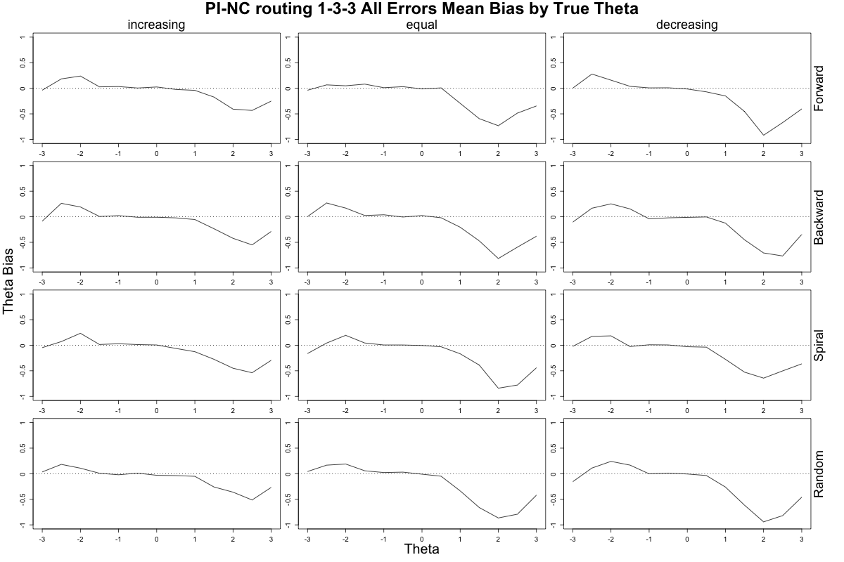

**Figure S-3. Mean Conditional Bias (continued)**

1. **Population Distribution Interval, Number-Correct Based Routing, 1-3-4 Design**

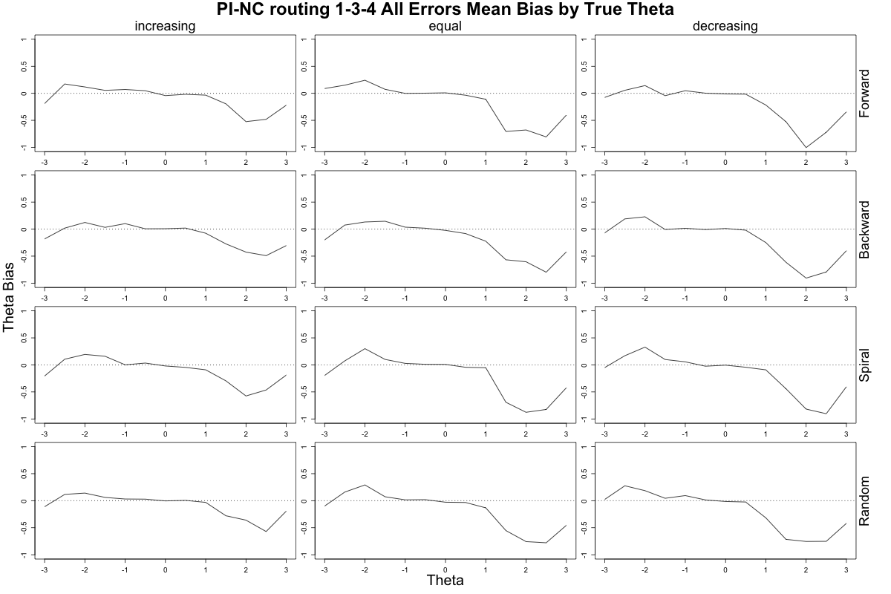

**Figure S-4. Mean Conditional Bias by Number of Routing Errors**

1. **Maximum Information-Based Routing, 1-3-3 Design**

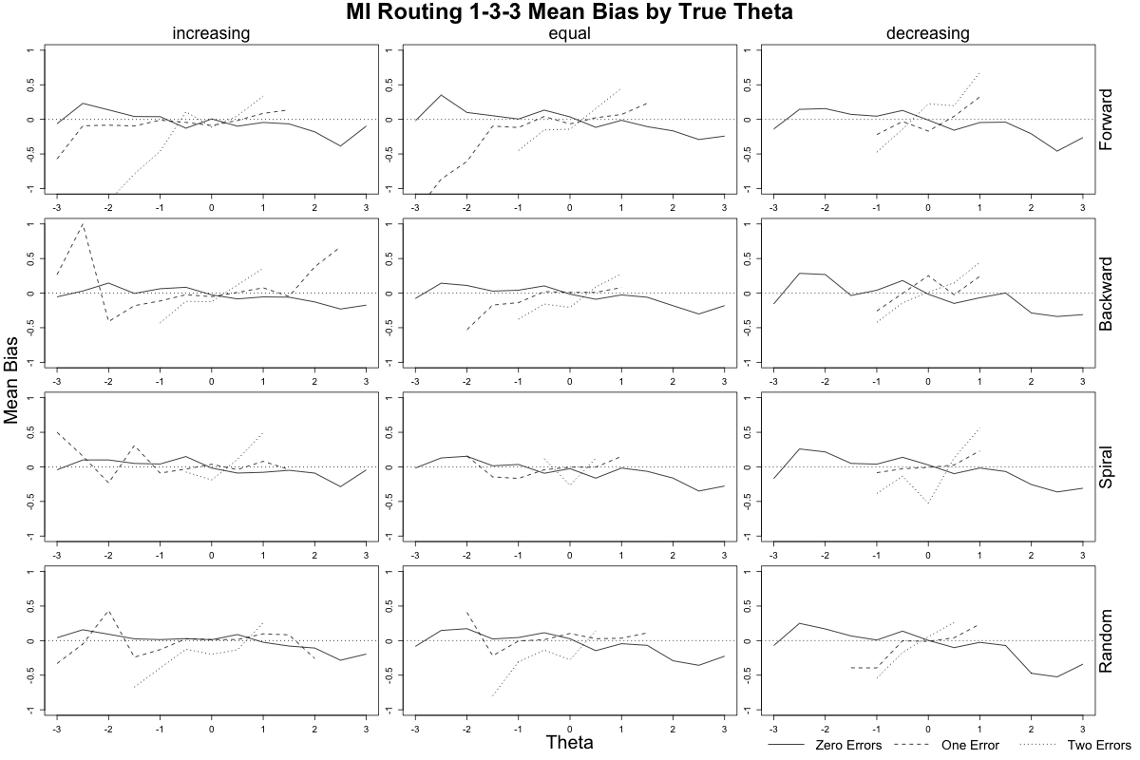

**Figure S-4. Mean Conditional Bias by Number of Routing Errors (continued)**

1. **Maximum Information-Based Routing, 1-3-4 Design**

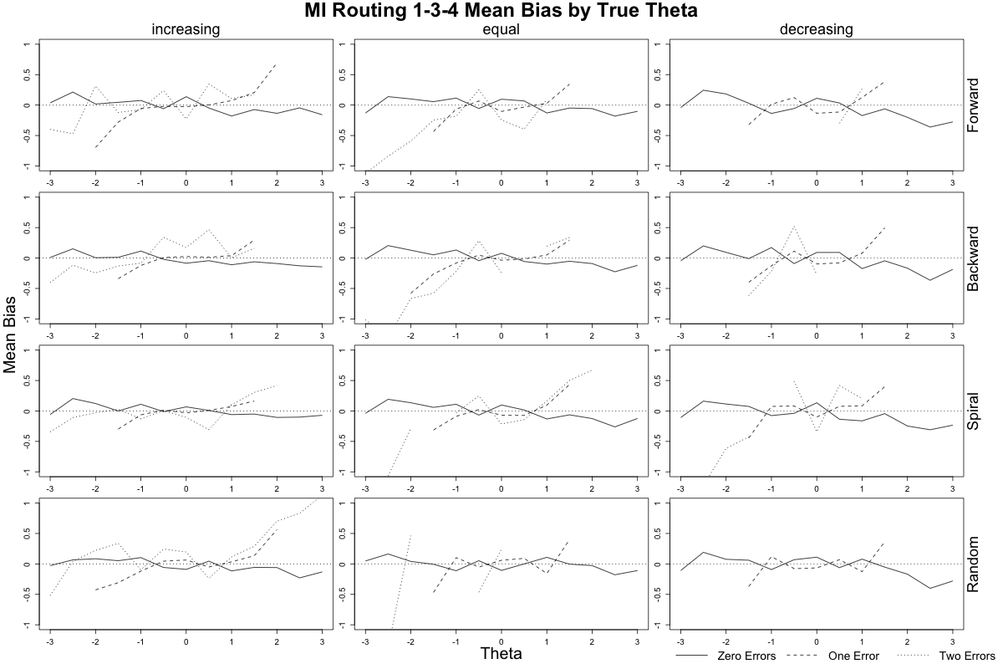

**Figure S-4. Mean Conditional Bias by Number of Routing Errors (continued)**

1. **Population Distribution Interval, θ-Based Routing, 1-3-3 Design**

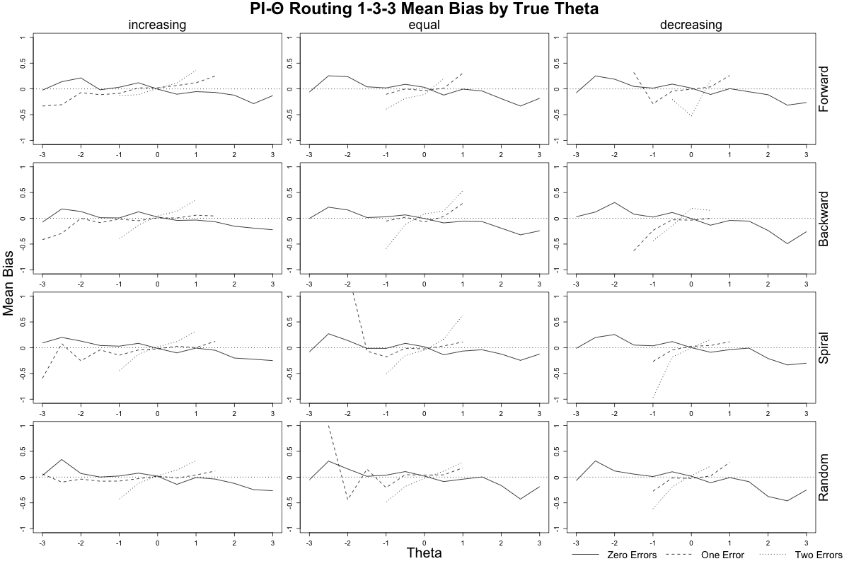

1. **Figure S-4. Mean Conditional Bias by Number of Routing Errors (continued)**
2. **Population Distribution Interval, θ-Based Routing, 1-3-4 Design**

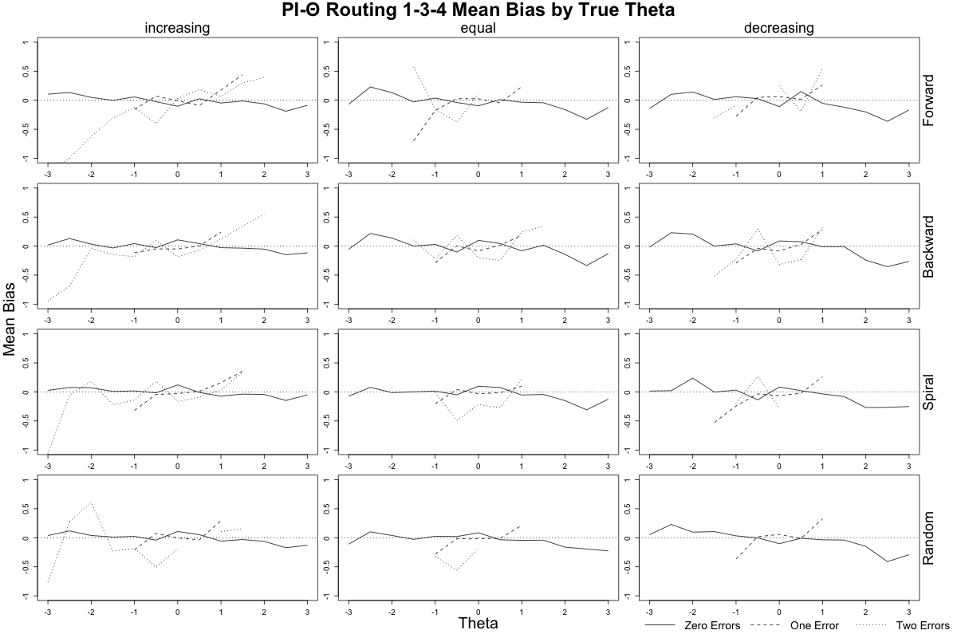

1. **Figure S-4. Mean Conditional Bias by Number of Routing Errors (continued)**
2. **Population Distribution Interval, Number-Correct Based Routing, 1-3-3 Design**

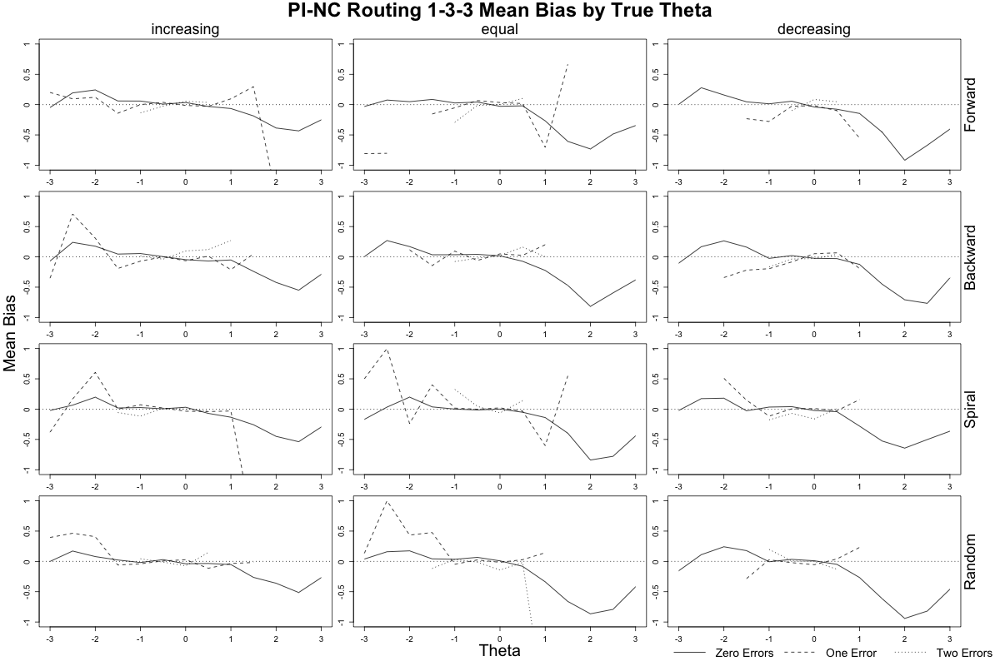

1. **Figure S-4. Mean Conditional Bias by Number of Routing Errors (continued)**
2. **Population Distribution Interval, Number-Correct Based Routing, 1-3-4 Design**

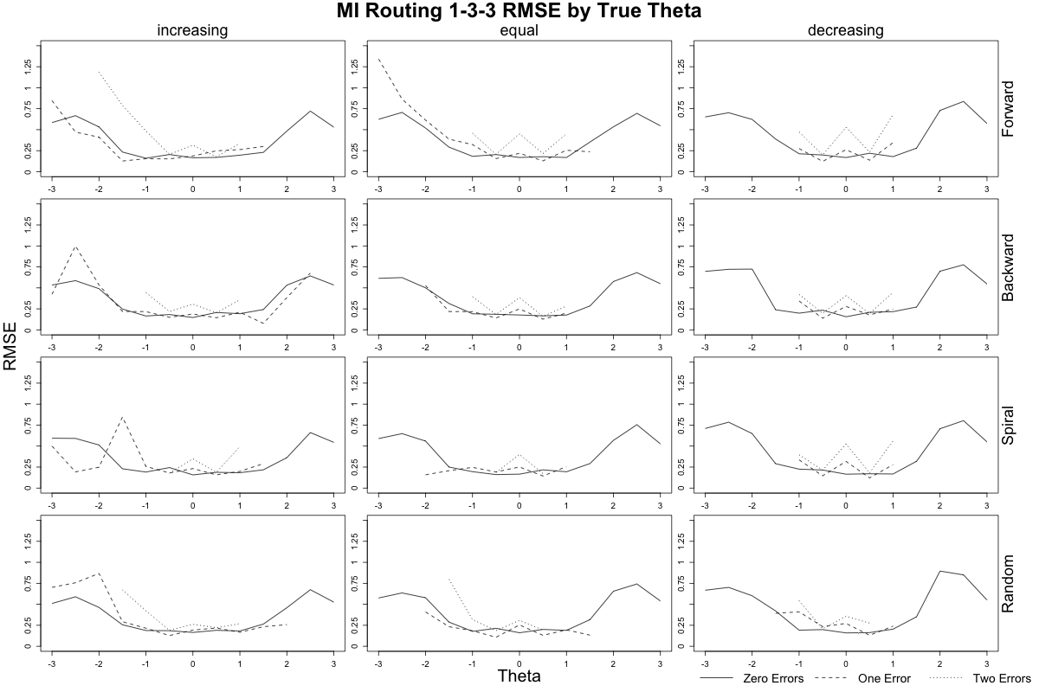

**Figure S-5. Conditional RMSE by Number of Routing Errors**

1. **Maximum Information-Based Routing, 1-3-3 Design**



**Figure S-5. Conditional RMSE by Number of Routing Errors (continued)**

1. **Maximum Information-Based Routing, 1-3-4 Design**

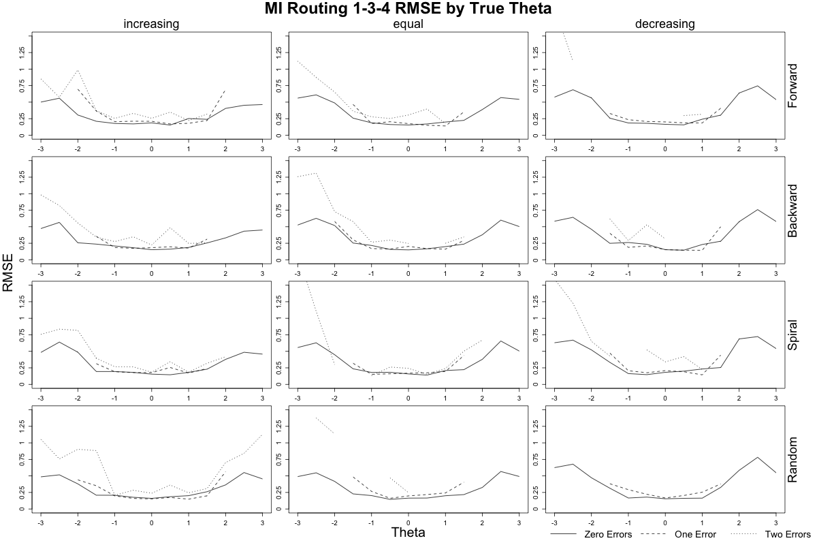

1. **Figure S-5. Conditional RMSE by Number of Routing Errors (continued)**
2. **Population Distribution Interval , *θ* -Based Routing, 1-3-3 Design**

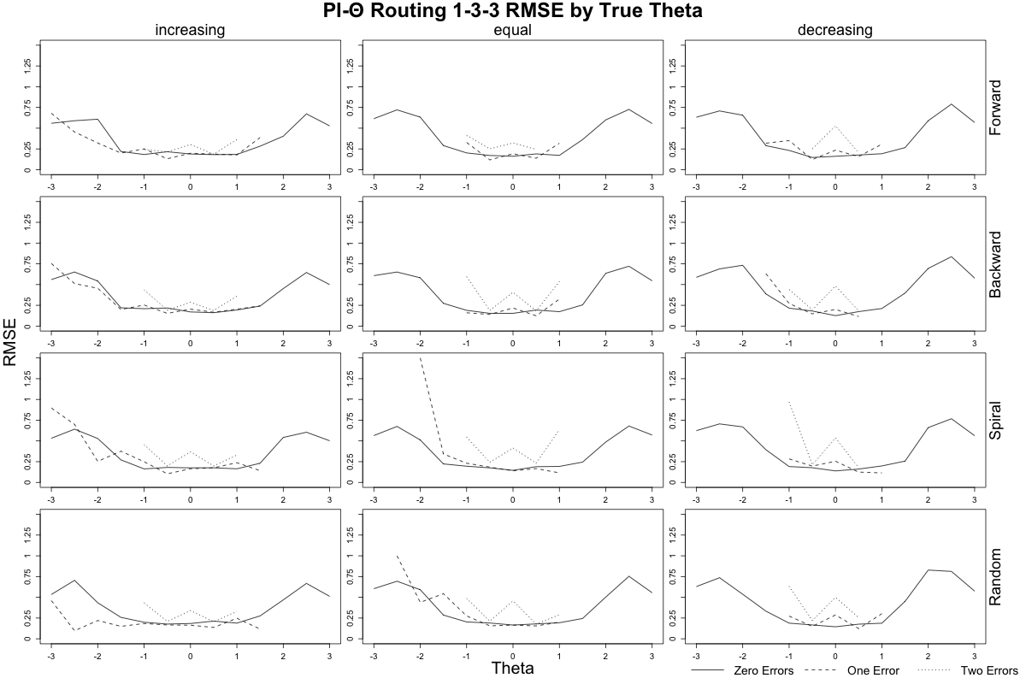

**Figure S-5. Conditional RMSE by Number of Routing Errors (continued)**

1. **Population Distribution Interval, *θ*-Based Routing, 1-3-4 Design**

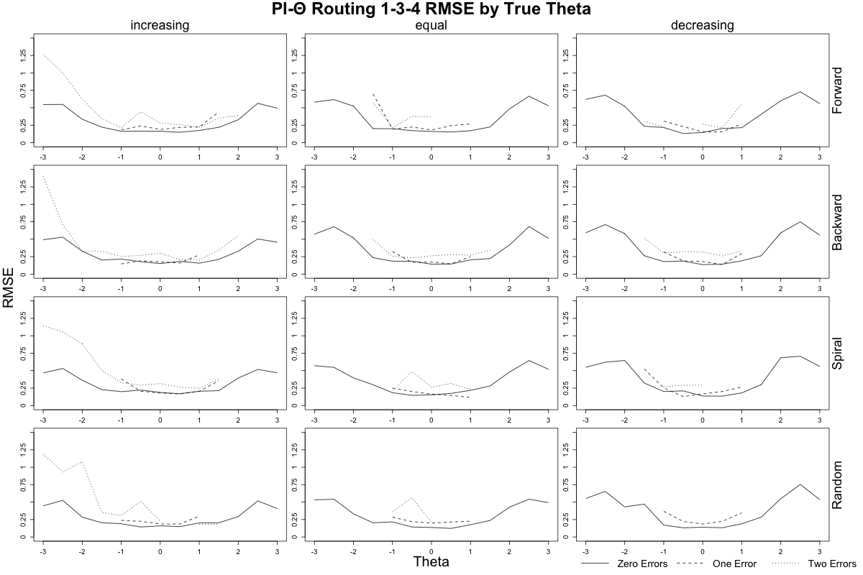

**Figure S-5. Conditional RMSE by Number of Routing Errors (continued)**

1. **Population Distribution Interval, Number-Correct Based Routing, 1-3-3 Design**

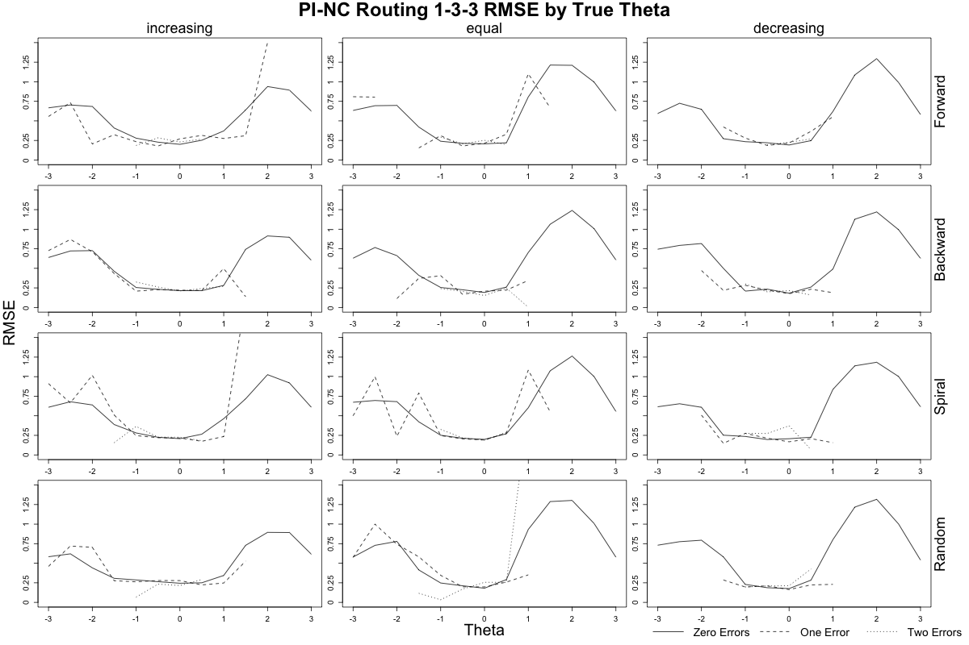

**Figure S-5. Conditional RMSE by Number of Routing Errors (continued)**

1. **Population Distribution Interval, Number-Correct Based Routing, 1-3-4 Design**

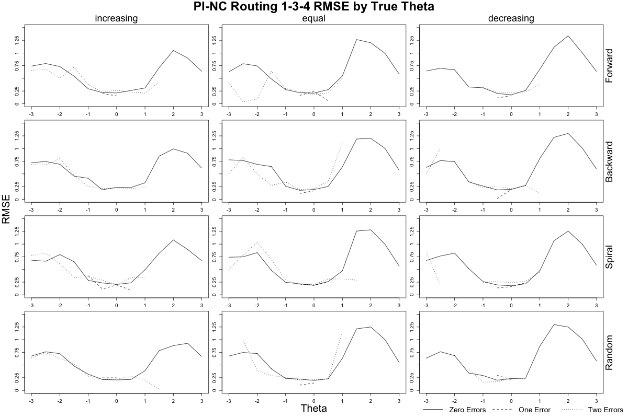

**Figure S-6. Mean Conditional SEM by Number of Routing Errors**

1. **Maximum Information-Based Routing, 1-3-3 Design**

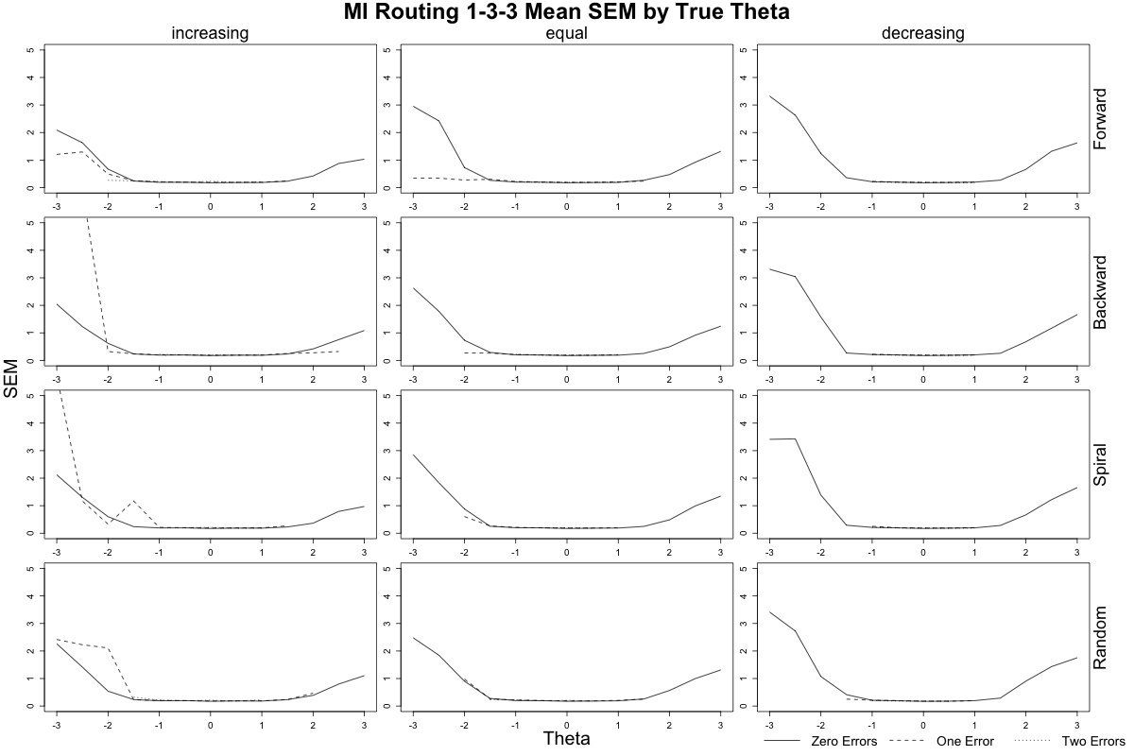

**Figure S-6. Mean Conditional SEM by Number of Routing Errors (continued)**

1. **Maximum Information-Based Routing, 1-3-4 Design**

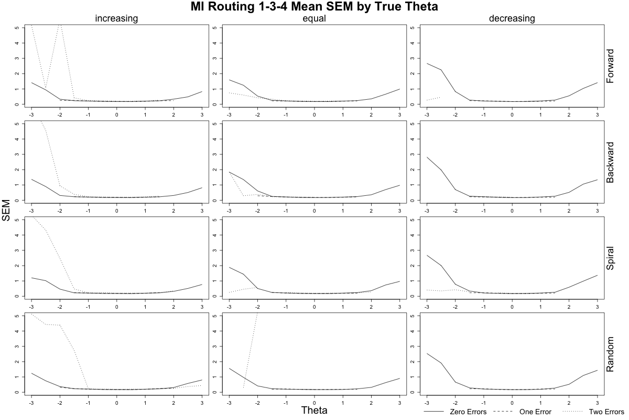

**Figure S-6. Mean Conditional SEM by Number of Routing Errors (continued)**

1. **Population Distribution Interval, θ-Based Routing, 1-3-3 Design**

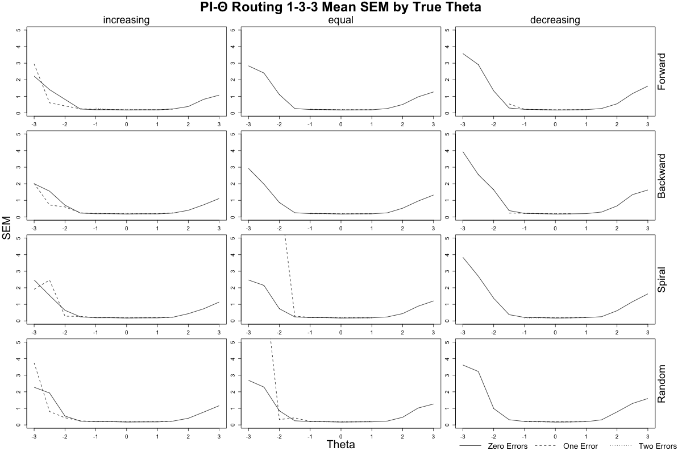

**Figure S-6. Mean Conditional SEM by Number of Routing Errors (continued)**

1. **Population Distribution Interval –** θ **Based Routing, 1-3-4 Design**

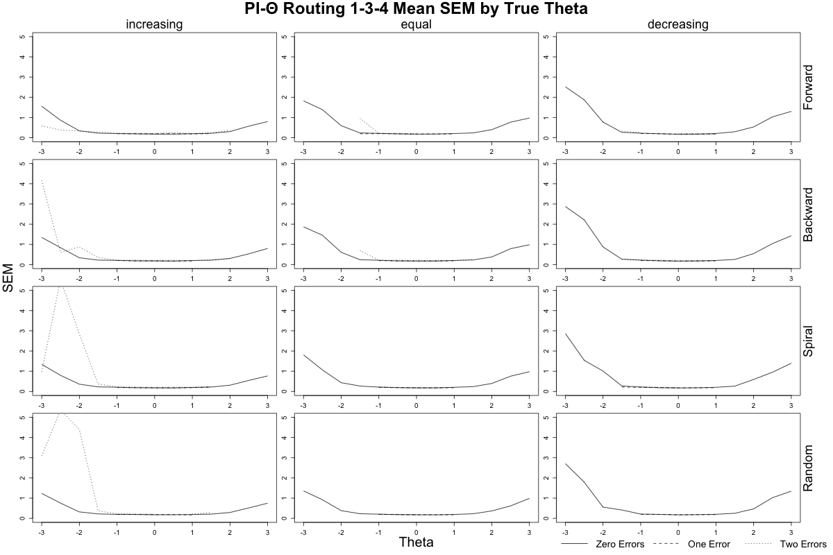

**Figure S-6. Mean Conditional SEM by Number of Routing Errors (continued)**

1. **Population Distribution Interval, Number-Correct Based Routing, 1-3-3 Design**

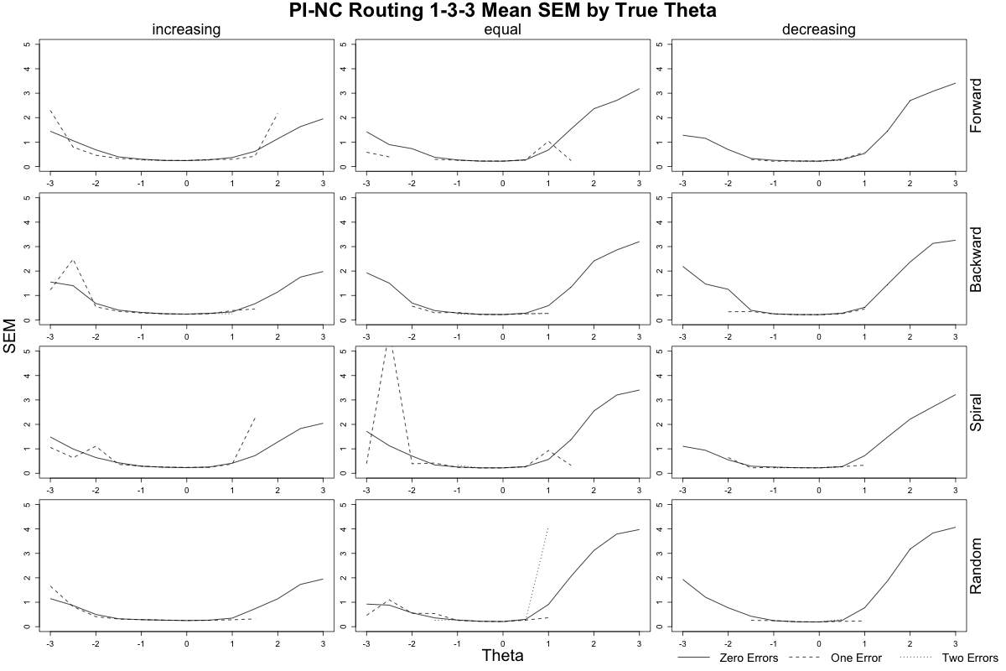

**Figure S-6. Mean Conditional SEM by Number of Routing Errors (continued)**

1. **Population Distribution Interval, Number-Correct Based Routing, 1-3-4 Design**

**Table S-1. Overall Mean Bias, RMSE, SEM and Percent Error   
by Path, Assembly Method, Number of Items, and Routing Method for 1-3-3 Tests**

|  |  |  |  |  |  |  |  |  |  |  |  |  |  |  |  |  |  |  |  |  |  |
| --- | --- | --- | --- | --- | --- | --- | --- | --- | --- | --- | --- | --- | --- | --- | --- | --- | --- | --- | --- | --- | --- |
| a. Assembly Method | | | | | | | | | | | | | | | | | | | | | |
| Path | Forward | | | | | Backward | | | | Spiral | | | | | Random | | | | | | |
| Bias | RMSE | SEM | % Error | Bias | | RMSE | SEM | % Error | Bias | RMSE | SEM | % Error | Bias | | RMSE | SEM | | % Error | |
| 1-2-5 | 0.083 | 0.516 | 1.069 | 1% | 0.080 | | 0.528 | 1.122 | 1% | 0.070 | 0.505 | 1.057 | 1% | 0.080 | | 0.510 | 1.032 | | 1% | |
| 1-3-5 | -0.032 | 0.301 | 0.327 | 100% | -0.033 | | 0.341 | 0.382 | 100% | 0.025 | 0.375 | 0.438 | 100% | 0.049 | | 0.352 | 0.475 | | 100% | |
| 1-2-6 | -0.002 | 0.203 | 0.206 | 100% | -0.008 | | 0.187 | 0.198 | 100% | -0.031 | 0.212 | 0.198 | 100% | 0.002 | | 0.182 | 0.198 | | 100% | |
| 1-3-6 | -0.006 | 0.207 | 0.192 | 39% | -0.011 | | 0.192 | 0.194 | 45% | -0.003 | 0.201 | 0.192 | 40% | -0.004 | | 0.212 | 0.193 | | 39% | |
| 1-4-6 | -0.025 | 0.229 | 0.196 | 100% | -0.013 | | 0.188 | 0.192 | 100% | -0.013 | 0.201 | 0.200 | 100% | -0.020 | | 0.191 | 0.194 | | 100% | |
| 1-3-7 | -0.028 | 0.332 | 0.260 | 100% | -0.001 | | 0.216 | 0.220 | 100% | -0.042 | 0.292 | 0.247 | 100% | -0.003 | | 0.205 | 0.216 | | 100% | |
| 1-4-7 | -0.233 | 0.637 | 0.967 | 1% | -0.239 | | 0.628 | 0.964 | 1% | -0.235 | 0.630 | 0.966 | 2% | -0.280 | | 0.668 | 1.112 | | 2% | |
|  |  |  |  |  |  | |  |  |  |  |  |  |  |  | |  |  | |  | |
|  | | | | | | | | | | | | | | |  |  | |  | |  | |
| b. Number of Items | | | | | | | | | | | | | | |  |  | |  | |  | |
| Path | Increasing | | | | | Equal | | | | Decreasing | | | | |  |  | |  | |  | |
| Bias | RMSE | SEM | % Error | Bias | | RMSE | SEM | % Error | Bias | RMSE | SEM | % Error |  | |  |  | |  | |
| 1-2-5 | 0.073 | 0.482 | 0.865 | 1% | 0.074 | | 0.511 | 1.027 | 1% | 0.088 | 0.546 | 1.297 | 0% |  | |  |  | |  | |
| 1-3-5 | 0.008 | 0.388 | 0.500 | 100% | 0.010 | | 0.312 | 0.328 | 100% | -0.025 | 0.241 | 0.267 | 100% |  | |  |  | |  | |
| 1-2-6 | -0.011 | 0.201 | 0.202 | 100% | 0.007 | | 0.191 | 0.201 | 100% | -0.026 | 0.193 | 0.196 | 100% |  | |  |  | |  | |
| 1-3-6 | -0.006 | 0.208 | 0.200 | 44% | 0.000 | | 0.204 | 0.193 | 41% | -0.013 | 0.197 | 0.187 | 37% |  | |  |  | |  | |
| 1-4-6 | -0.026 | 0.213 | 0.199 | 100% | -0.010 | | 0.193 | 0.194 | 100% | -0.009 | 0.194 | 0.190 | 100% |  | |  |  | |  | |
| 1-3-7 | -0.031 | 0.270 | 0.238 | 100% | -0.007 | | 0.301 | 0.248 | 100% | -0.008 | 0.208 | 0.217 | 100% |  | |  |  | |  | |
| 1-4-7 | -0.181 | 0.543 | 0.708 | 3% | -0.269 | | 0.674 | 1.102 | 1% | -0.289 | 0.695 | 1.191 | 1% |  | |  |  | |  | |
|  |  |  |  |  |  | |  |  |  |  |  |  |  |  | |  |  | |  | |
|  | | | | | | | | | | | | | | |  |  | |  | |  | |
| c. Routing Method | | | | | | | | | | | | | | |  |  | |  | |  | |
| Path | Information | | | | | *θ* Cutscore | | | | Number Correct | | | | |  |  | |  | |  | |
| Bias | RMSE | SEM | % Error | Bias | | RMSE | SEM | % Error | Bias | RMSE | SEM | % Error |  | |  |  | |  | |
| 1-2-5 | 0.072 | 0.494 | 1.201 | 1% | 0.091 | | 0.493 | 1.243 | 1% | 0.072 | 0.556 | 0.762 | 1% |  | |  |  | |  | |
| 1-3-5 | -0.017 | 0.329 | 0.484 | 100% | -0.019 | | 0.302 | 0.398 | 100% | 0.026 | 0.371 | 0.364 | 100% |  | |  |  | |  | |
| 1-2-6 | -0.012 | 0.202 | 0.195 | 100% | -0.012 | | 0.177 | 0.194 | 100% | 0.003 | 0.226 | 0.232 | 100% |  | |  |  | |  | |
| 1-3-6 | -0.007 | 0.196 | 0.180 | 39% | -0.005 | | 0.192 | 0.179 | 43% | -0.007 | 0.226 | 0.231 | 39% |  | |  |  | |  | |
| 1-4-6 | -0.027 | 0.206 | 0.189 | 100% | 0.005 | | 0.185 | 0.189 | 100% | -0.081 | 0.258 | 0.250 | 100% |  | |  |  | |  | |
| 1-3-7 | 0.001 | 0.205 | 0.196 | 100% | -0.016 | | 0.188 | 0.193 | 100% | -0.032 | 0.336 | 0.290 | 100% |  | |  |  | |  | |
| 1-4-7 | -0.175 | 0.503 | 0.637 | 1% | -0.160 | | 0.492 | 0.619 | 1% | -0.394 | 0.846 | 1.699 | 3% |  | |  |  | |  | |

**Table S-2. Overall Mean Bias, RMSE and SEM   
by Path, Assembly Method, Number of Items, and Routing Method for 1-3-4 Tests**

|  |  |  |  |  |  |  |  |  |  |  |  |  |  |  |  |  |
| --- | --- | --- | --- | --- | --- | --- | --- | --- | --- | --- | --- | --- | --- | --- | --- | --- |
| a. Assembly Method | | | | | | | | | | | | | | | | |
| Path | Forward | | | | Backward | | | | Spiral | | | | Random | | | |
| Bias | RMSE | SEM | % Error | Bias | RMSE | SEM | % Error | Bias | RMSE | SEM | % Error | Bias | RMSE | SEM | % Error |
| 1-2-5 | 0.067 | 0.511 | 0.851 | 4% | 0.065 | 0.515 | 0.881 | 5% | 0.068 | 0.527 | 0.860 | 6% | 0.070 | 0.488 | 0.835 | 5% |
| 1-2-6 | -0.017 | 0.210 | 0.199 | 62% | -0.015 | 0.199 | 0.198 | 100% | -0.020 | 0.202 | 0.199 | 81% | -0.014 | 0.198 | 0.195 | 33% |
| 1-3-6 | -0.015 | 0.300 | 0.326 | 63% | -0.030 | 0.301 | 0.324 | 35% | -0.019 | 0.318 | 0.344 | 37% | 0.005 | 0.346 | 0.451 | 69% |
| 1-3-7 | -0.012 | 0.195 | 0.193 | 51% | -0.018 | 0.213 | 0.199 | 59% | -0.011 | 0.211 | 0.199 | 62% | 0.000 | 0.226 | 0.199 | 56% |
| 1-4-7 | -0.003 | 0.201 | 0.188 | 73% | -0.005 | 0.185 | 0.186 | 79% | -0.018 | 0.199 | 0.189 | 79% | 0.003 | 0.189 | 0.183 | 29% |
| 1-4-8 | -0.243 | 0.638 | 0.986 | 3% | -0.241 | 0.636 | 1.023 | 2% | -0.245 | 0.636 | 0.979 | 3% | -0.244 | 0.637 | 1.016 | 4% |
|  |  |  |  |  |  |  |  |  |  |  |  |  |  |  |  |  |
| b. Number of Items | | | | | | | | | | | | |  |  |  |  |
| Path | Increasing | | | | Equal | | | | Decreasing | | | |  |  |  |  |
| Bias | RMSE | SEM | % Error | Bias | RMSE | SEM | % Error | Bias | RMSE | SEM | % Error |  |  |  |  |
| 1-2-5 | 0.058 | 0.486 | 0.670 | 5% | 0.063 | 0.513 | 0.807 | 4% | 0.081 | 0.530 | 1.075 | 6% |  |  |  |  |
| 1-2-6 | -0.014 | 0.208 | 0.198 | 86% | -0.020 | 0.198 | 0.195 | 63% | -0.014 | 0.201 | 0.201 | 55% |  |  |  |  |
| 1-3-6 | -0.018 | 0.393 | 0.575 | 57% | -0.014 | 0.284 | 0.246 | 51% | -0.013 | 0.221 | 0.199 | 40% |  |  |  |  |
| 1-3-7 | -0.002 | 0.211 | 0.198 | 60% | -0.020 | 0.230 | 0.202 | 56% | -0.009 | 0.192 | 0.193 | 54% |  |  |  |  |
| 1-4-7 | -0.019 | 0.204 | 0.190 | 72% | 0.002 | 0.188 | 0.184 | 60% | 0.002 | 0.188 | 0.185 | 59% |  |  |  |  |
| 1-4-8 | -0.159 | 0.535 | 0.679 | 4% | -0.260 | 0.653 | 1.082 | 4% | -0.311 | 0.710 | 1.245 | 3% |  |  |  |  |
|  |  |  |  |  |  |  |  |  |  |  |  |  |  |  |  |  |
| c. Routing Method | | | | | | | | | | | | |  |  |  |  |
| Path | Information | | | | Theta Cutscore | | | | Number Correct | | | |  |  |  |  |
| Bias | RMSE | SEM | % Error | Bias | RMSE | SEM | % Error | Bias | RMSE | SEM | % Error |  |  |  |  |
| 1-2-5 | 0.076 | 0.468 | 0.951 | 4% | 0.060 | 0.443 | 0.849 | 4% | 0.067 | 0.599 | 0.785 | 6% |  |  |  |  |
| 1-2-6 | -0.022 | 0.208 | 0.200 | 73% | -0.009 | 0.193 | 0.193 | 58% | 0.030 | 0.210 | 0.218 | 100% |  |  |  |  |
| 1-3-6 | -0.032 | 0.334 | 0.455 | 38% | -0.027 | 0.275 | 0.269 | 50% | 0.015 | 0.327 | 0.325 | 64% |  |  |  |  |
| 1-3-7 | 0.000 | 0.188 | 0.178 | 62% | -0.005 | 0.188 | 0.178 | 59% | -0.028 | 0.256 | 0.241 | 49% |  |  |  |  |
| 1-4-7 | 0.002 | 0.192 | 0.186 | 64% | -0.016 | 0.196 | 0.184 | 62% | -0.064 | 0.225 | 0.227 | 100% |  |  |  |  |
| 1-4-8 | -0.144 | 0.464 | 0.571 | 2% | -0.139 | 0.447 | 0.524 | 5% | -0.408 | 0.853 | 1.742 | 3% |  |  |  |  |